**Titration errors**

All measurements have associated errors and uncertainties.

It is important to understand these uncertainties and to know the maximum error/uncertainty that a measurement can tolerate.

The variability of a measurement cannot be determined from a single measurement, therefore multiple measurements (replicates) are made to check reproducibility.

Precision = reproducibility of a measurement

The replicate measurements are very rarely exactly the same. Therefore, a central value is taken as the best estimate.

Accuracy = closeness of a measurement to the true or accepted value

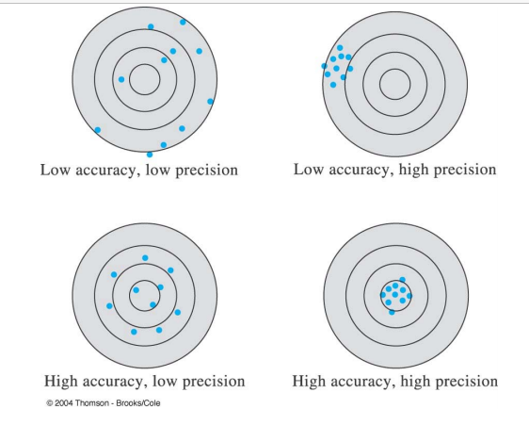

**Types of errors:**

Random (or in determinant): data are scattered more or less symmetrically about the central value (precision reflects random error)

Systematic (or determinant): constant deviation (in sign and magnitude) from central value (accuracy affected by systematic error)

systematic errors lead to bias in results whereby a series of replicate measurements may all be high or low.

**Systematic errors**

A systematic error is an error that is constant or drifting slightly and is due to a consistent mistake made during the analysis.

Typical systematic errors in titration analyses include:

• Differing or incorrect analytical method compared to that used to determine the ‘true’ value

• Incorrect calculation formulas

• Sampling errors

• Sample size errors e.g. due to a constant weighing error

• Incorrect titrant concentration

• False or missing blank value

• Incorrect or missing sensor adjustment

• Too high titration speed for the chemical reaction

• Too high titration speed for the electrode response Once the source of a systematic error is identified it is usually easy to correct for these errors.

**Random errors**

A random error is a component of the overall error that varies in an unpredictable fashion. It is usually difficult to identify these errors.

Typical sources of random errors include:

• Poor sample handling

• Inadequate equipment e.g. too low balance resolution, wrong grade of glassware etc.

• Incorrect method parameters e.g. too large increments, insufficient waiting time between increments.

• Bubbles in burette tubes

• Ineffective rinsing between samples

• Lack of operator training

• Inadequate environmental conditions e.g. temperature and humidity fluctuations

If the source of a random error cannot be identified, then the only solution is to increase the number of replicates in order to get a more trustworthy mean value. This generally leads to waste of sample, reagents and time